**📘 User Manual: Secure Communication System**

**Author:** Valento Bardhoshi

**📌 Introduction**

This manual describes the steps for installing, configuring, and using the developed secure communication application. The system provides message encryption using the Caesar Cipher and Vigenère Cipher algorithms, as well as user authentication for storing and viewing the message history.

**💻 System Requirements**

To install and use the application, you need:

* Java JDK 8 or newer
* NetBeans IDE (or any Java-supporting IDE)
* SQLite JDBC driver (included in the project)

**🧩 Installation**

**📥 Download the Source Code**

Download the application’s source code from the provided link or repository.

**🗃 Include SQLite JDBC**

Ensure the sqlite-jdbc-x.x.x.jar file is included in your project:

* In NetBeans, right-click on Libraries, then click **Add JAR/Folder**
* Select and add the SQLite JAR file

**🛠 Compile the Code**

* Open the project in the IDE
* Ensure there are no errors
* Click **Build Project** to compile

**▶️ Run the Application**

* Click **Run** to start the application

**🧑‍💻 Usage**

**🔐 Register a New User**

1. Click the **Register** button
2. Fill in the username and password fields
3. Click **Register** to save the account  
   A screenshot of a computer

   Description automatically generated

**🔓 Log In**

1. Return to the login panel
2. Enter your username and password
3. Click **Login** to access the system  
   A screenshot of a computer

   Description automatically generated

**🔏 Encrypting Messages**

1. Select **Encrypt Message** from the main panel
2. Enter the message you want to encrypt
3. Choose your preferred algorithm:
   * **Caesar Cipher**: Enter a numeric key
   * **Vigenère Cipher**: Enter a text key
4. Click **OK** — the encrypted message is automatically saved in the database  
   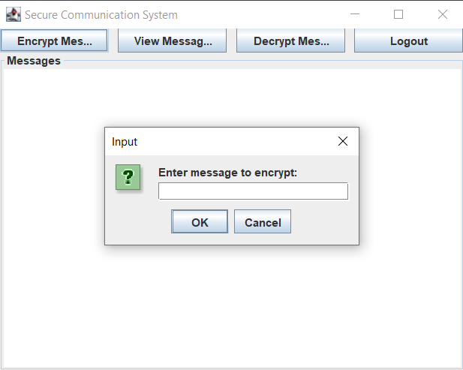

**📨 Viewing Encrypted Messages**

* Select **View Messages**
* Encrypted messages will be displayed in a separate window  
  A screenshot of a computer

  Description automatically generated

**🔓 Decrypting Messages**

1. Select **Decrypt Messages**
2. Enter the encrypted message and the key used
3. Choose the algorithm
4. Click **OK** — the decrypted message will be shown  
   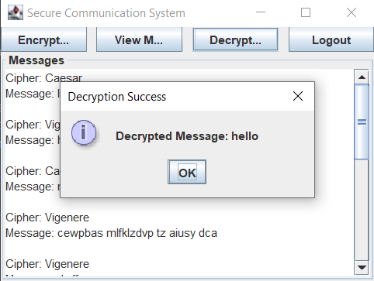

**🚪 Logging Out**

* Click the **Logout** button to exit your account

**⚙️ Key Functionalities**

**Caesar Cipher**

* A simple algorithm that shifts characters based on a numeric key
* Suitable for short messages

**Vigenère Cipher**

* Uses a long text key for stronger encryption
* More secure than Caesar Cipher

**Authentication & Message Management**

* Each user has their own account
* Encrypted messages are stored and managed per user